**Mild to Moderate evaluation**

Sample_id :**GDR6DV(Cat)**

Link: <https://release.animalbiome.com/pet/assessment/report/c7861af2-f473-4598-9694-9c3f79bc1de2>

Mild to Moderate

Cats and dogs:

Any Two

(High Yellow Flag Megamonas OR (failed)

High Yellow Flag Sutterella OR (failed)

High Yellow Flag Collinsella OR (failed)

Low Yellow Flag Bacteroides OR (failed)

Low Yellow Flag Blautia (failed)

)

OR

Dogs: 8-10 Yellow Flags: (**passed**)

OR 5-8 Red Flags: (**failed**)

OR diet recommendation of increase fibre (**passed**)

OR diet recommendation of increase protein (**failed**)

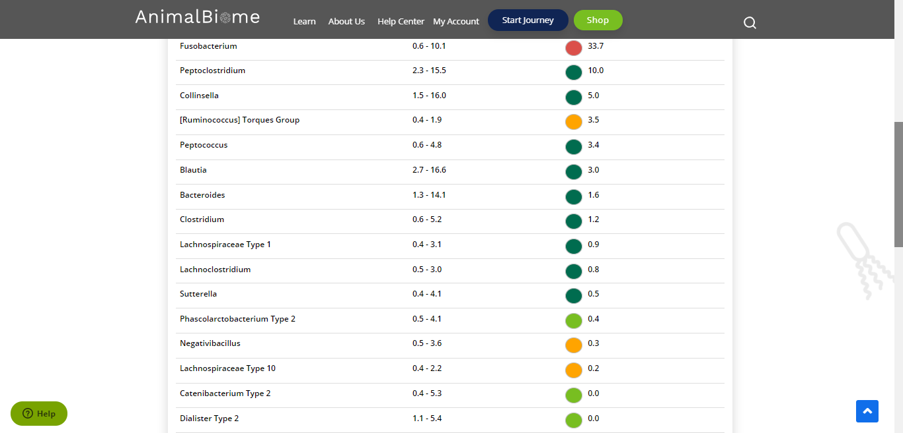



The result: **False True False True**

Expected result: Mild to Moderate

Achieved result: passed

